**PROJECT REPORT ON**

**Alienware**

**Submitted to**



**Developed By**

***Dwarkesh Gohel***

***Kishan Parmar***

***Bhavya Fofandi***

**BCA SEM – VI 2020-21**

**Guided By**

Mr.Himanshu Sir

**Affiliated By:**

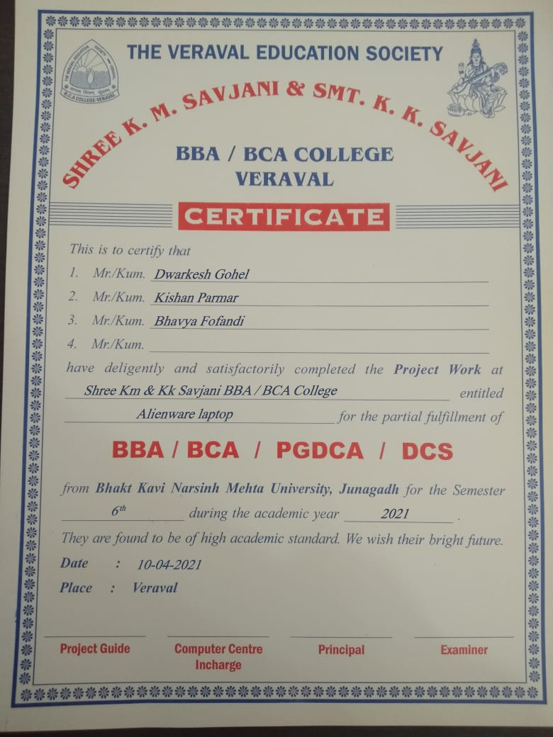**INDEX**

|  |  |  |
| --- | --- | --- |
| **Sr.no** | **Title** | **Page No** |
| **1** | **Preface** | **02** |
| **2** | **Acknowledgement** | **03** |
| **3** | **Project Profile** | **04** |
| **4** | **SDLC Implementation** | **06** |
| **5** | **Feasibility Study** | **07** |
| **6** | **About Project** | **09** |
| **7** | **Data dictionary** | **11** |
| **8** | **Screenshots & Codes** | **13** |
| **9** | **Data Flow Diagram** | **34** |
| **10** | **ER Diagram** | **37** |
| **11** | **Testing** | **39** |
| **12** | **Limitations** | **41** |
| **13** | **Future Enhancement** | **41** |
| **14** | **Bibliography** | **42** |
| **15** | **Reference** | **42** |

**➔PREFACE**

We are pleased to announce our **ALIEANWARE** project report before you we are student of BCA.Our project work as a dynamic web site that is why our college has made an arrangement all kind of help for us.

Our project work focus to Sell the Best Laptop, customer efforts so easier and so faster with same extra ordinary facility.

It was developed using SQL SERVER- as a Backend and ASP.NET with C# as a Front end of project.

# ➔ACKNOWLEDGEMENT

## The presentation of this report gives us the feeling of fulfillment. The project report submitted in partial fulfillment of award of BCA SEM-6 degree.

We are grateful to Principal **Dr. JigarRaval Sir** and our project guide **Mr. Himanshu Sir** who has given us the opportunity to carry the project under this title.

Lastly we will be falling in my duties if we do not mention out thanks to our parents and amity members or their constant motivation blessing.

➔PROJECT PROFILE

|  |  |
| --- | --- |
| Project Title | - ALIENWARE |
| Project category | - Web Development |
| Front End | -Visual Studio 2019 ASP.NET with C# |
| Back End | -Local Database |
| Browser | - Google Chrome |
| Operating System | -Windows |
| Documentation | -Microsoft Word 2018 |
| Developed By | -Dwarkesh Gohel, Kishan Parmar, Bhavya Fofandi |
| Project Guide | -Mr. Himanshu sir |
| Submitted To | -Shree K.M & SMT K.K Savjani College. |

➔SDLC MODEL

Primary Investigation



### Determination of system Requirements

Design of system

Development of Software

System Testing

Implementation Evaluation & Maintenance

# Preliminary Investigation:

### For requirement gathering of our application we have visited ORIGINAL Alienware Website.

It give the information about Website Design and it is so useful in our project.

1. Determination Of System Requirement:

Functional requirements of a system are considered here. It is also system analysis takes place – or analyzing the needs of the end users to ensure the new system can meet their expectations.

1. Design

In Designing When user Comes To Home Page There user Can See The Main AlienWare Laptop

If User Wants To buy then User must have to Register or if User have already account then Login to that Account After user Van Purchase the Product.

All this designing done by using CSS and its properties

1. Development Of Software

On receiving System Design Documents the work is divided in modules and actual coding is started.

This section describes the support software, materials, equipment, and facilities required for the implementation, as well as the personnel requirements and training necessary for the implementation. The information provided in this section is not site-specific.

1. Testing

After the code is development it is tested against the requirements make sure that the product is actually solving the needs addressed and gathered during the requirement phase. During this phase unit testing, integration test, system testing.

1. Implementation, Evaluation & Maintenance

Once when the customers starts using the develop system then the actual problems comes up and to be solved from time to time.

.........................................................................................................

*Feasibility Study*

.........................................................................................................

Feasibility study is test of a system proposal according to its workability, impact on the organization, ability to meet user needs and effective use of resources. All the projects are feasibility given unlimited resources and infinite time! Ergo, feasibility study means an evaluation of benefits versus costs incurred in developing project, where cost includes manpower, time, resources and money.

A purposed of feasibility study is to check out the possibility of a computerized solution to the organization’s observed problem before very much money that has been spent on.

A feasibility study is carried out to select the best system that meets performance requirements. Only by spending the time to evaluate the feasibility do I reduce the chances for extreme embarrassment at later stage of the system project.

.........................................................................................................

*Technical Feasibility:*

.........................................................................................................

Technical analysis evaluates technical merits of the system at the same time collecting additional information about performance, reliability, maintainability and productivity.

*HARDWARE/SOFTWARE REQUIREMENT*

Software Requirement

|  |  |
| --- | --- |
| *Front-end* | *Visual Studio 2019 with C#* |
| *Back-end* | *Local Database* |
| *Browser* | *Google Chrome, Internet Explorer* |
| *Other Software* | *MS Word 2018* |
| *Operating System* | *Windows 10* |

Hardware Requirement

|  |  |
| --- | --- |
| *Processor Name* | *Intel(R) Core(TM) i5-7200U* |
| *Memory* | *12 GB RAM* |
| *HDD* | *1 TB HDD* |

.........................................................................................................

*Operational Feasibility:*

.........................................................................................................

Operational feasibility measures how well the solution will work in the organization and how will end-user &management feels about the system. Proposed system is helpful for all the users associated with the organization.

.........................................................................................................

*Economic Feasibility:*

.........................................................................................................

Among the most important information contained in feasibility study is the cost-benefit analysis. Here user can save money and time to choosing courses the administrator to have up-to-date information regarding all the aspect of their users. The decision-making process will also become faster with the use of data integration, consolidation. So it is feasible to implement the system

*ASP.NET*

After four years of development, and a series of beta releases in 2000 and 2001, ASP.NET 1.0 was released on January 5, 2002 as part of version 1.0 of the

.NET Framework. Even prior to the release, dozens of books had been written about ASP.NET, and Microsoft promoted it heavily as part of its platform for Web services.

Scott Guthrie became the product unit manager for ASP.NET, and development continued apace, with version 1.1 being released on April 24, 2003 as a part of Windows Server 2003. ASP.NET is loosely based on HTML. This release focused on improving ASP.NET's support for mobile devices.

ASP.NET is an open-source server-side web application framework designed for web development to produce dynamic web pages. It was developed by Microsoft to allow programmers to build dynamic web sites, web applications and web services.

It was first released in January 2002 with version 1.0 of the .NET Framework, and is the successor to Microsoft's Active Server Pages (ASP) technology. ASP.NET is built on the Common Language Runtime (CLR), allowing programmers to write ASP.NET code using any supported .NET language. The ASP.NET SOAP extension framework allows ASP.NET components to process SOAP messages.

ASP.NET's successor is ASP.NET Core. It is a re-implementation of ASP.NET as a modular web framework, together with other frameworks like Entity

Framework. The new framework uses the new open-source .NET Compiler Platform (codename "Roslyn") and is cross platform. ASP.NET MVC, ASP.NET Web API, and ASP.NET Web Pages.

*WHY TO USE ASP.NET IN OUR PROJECT?*

* ASP.NET was developed in direct response to the problems that developers had with classic ASP.
* Since ASP is in such wide use, however, Microsoft ensured that ASP scripts execute without modification on a machine with the .NET Framework (the ASP engine, ASP.DLL, is not modified when installing the .NET Framework).
* Thus, IIS can house both ASP and ASP.NET scripts on the same machine.
* ASP.NET runs efficiently on the server side.

*USE OF ASP.NET IN JALARAM BOOK STORES*

I have seen many tutorials on ASP.NET but most of them starts with coding and writing your first ASP.NET Program. But here I have written this tutorial for explaining why there is a need for ASP.NET when classy ASP is working fine and what is the underlying technology behind ASP.NET, What programming model ASP.NET Provides to programmers. Now let us get started.

ASP.NET is the new offering for Web developers from the Microsoft .It is not simply the next-generation of ASP; in fact, it is a completely re-engineered and enhanced technology that offers much, much more than traditional ASP and can increase productivity significantly.PHP is an official module of Apache HTTP server.

Because it has evolved from ASP, ASP.NET looks very similar to its predecessor—but only at first sight. Some items look very familiar, and they remind us of ASP. But concepts like Web Forms, Web Services, or Server Controls gives ASP.NET the power to build real Web applications.

*ADVANTAGES OF ASP.NET*

➔ This makes it much easier for teams of programmers and designers to collaborate efficiently. Easy to use.

➔ C#-support.

➔ Developer can use VB.NET and access features such as strong typing and object-oriented programming.

➔ Visual Studio .NET provides a very rich development environment for Web developers. (Apache, IIS, NETSCAPE enterprise).

➔ To refer to the problems mentioned before, ASP.NET provides solutions for session and application state management Speed.

*WHAT CAN ASP.NET DO?*

Microsoft Active Server Pages (ASP) is a server-side scripting technology. ASP is a technology that Microsoft created to ease the development of interactive Web applications. With ASP you can use client-side scripts as well as server-side scripts.

Maybe you want to validate user input or access a database. ASP provides solutions for transaction processing and managing session state. Asp is one of the most successful languages used in web development.

*WHAT IS C#?*

C# is an elegant and type-safe object-oriented language that enables developers to build a variety of secure and robust applications that run on the .NET Framework. You can use C# to create Windows client applications, XML Web services, distributed components, client-server applications, database applications, and much, much more.

Visual C# provides an advanced code editor, convenient user interface designers, integrated debugger, and many other tools to make it easier to develop applications based on the C# language and the .NET Framework.

*WHAT IS SQL-SERVER?*

SQL Server is Microsoft's relational database management system (RDBMS). It is a full-featured database primarily designed to compete against competitors Oracle Database (DB) and MySQL.

*THE MAIN FEATURES OF SQL-SERVER*

* + Supports most administrative tasks for SQL Server.
  + A single, integrated environment for SQL Server Database Engine management and authoring.
  + Dialogs for managing objects in the SQL Server Database Engine, Analysis Services, and Reporting Services, that allows you to execute your actions immediately, send them to a Code Editor, or script them for later execution.
  + Non-modal and resizable dialogs allow access to multiple tools while a dialog is open.
  + A common scheduling dialog that allows you to perform action of the management dialogs at a later time.
  + Exporting and importing SQL Server Management Studio server registration from one Management Studio environment to another.Save or print XML Showplan or Deadlock files generated by SQL Server Profiler, review them later, or send them to administrators for analysis.

***→DATA DICTIONARY***

***Orders***

|  |  |  |
| --- | --- | --- |
| ***FIELDTYPE*** | ***DATATYPE*** | ***SIZE*** |
| Name | *varchar* | *50* |
| Email | *nvarchar* | *50* |
| Contact No | *varchar* | *50* |
| Email | *varchar* | *50* |
| Address | *varchar* | *50* |

***REGISTRATION FORM***

|  |  |  |
| --- | --- | --- |
| ***FIELDTYPE*** | ***DATATYPE*** | ***SIZE*** |
| *Name* | *Varchar* | - |
| *Email* | *Varchar* | *50* |
| *Password* | *Varchar* | *50* |
| *State* | *Varchar* | *50* |
| *City* | *Varchar* | *50* |

*COADING AND SCREEN SHOTS*

………………………………………………………………………………………………………………………………………………………………….

SCREEN SHOTS

………………………………………………………………………………………………………………………………………………………………….

HOME PAGE PRODUCT PAGE

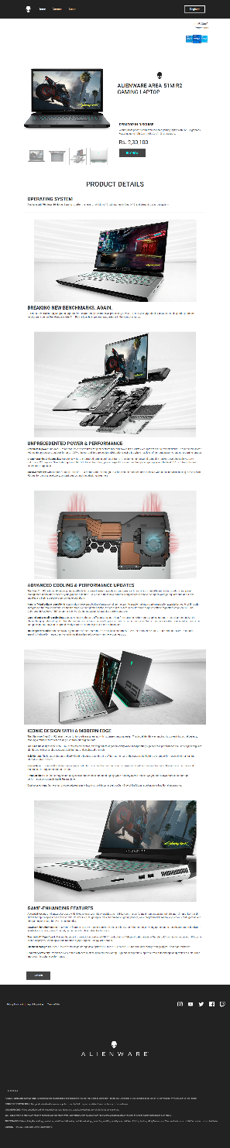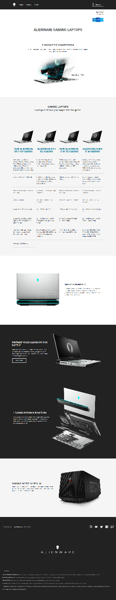

SIGNUP PAGE LOGIN PAGE

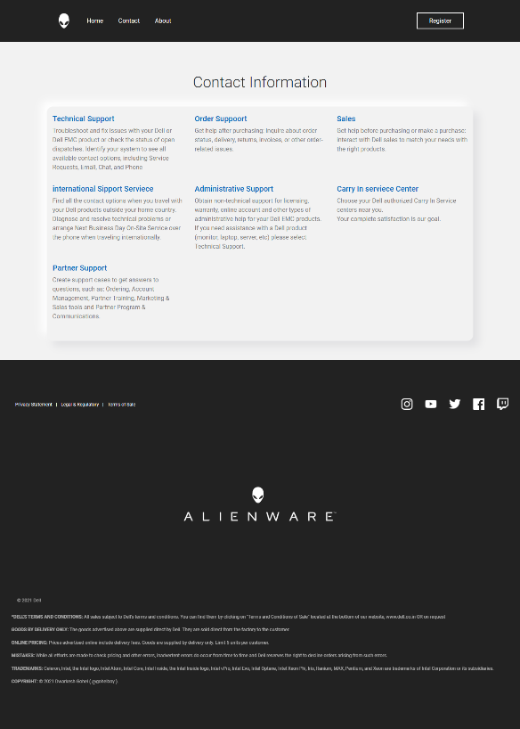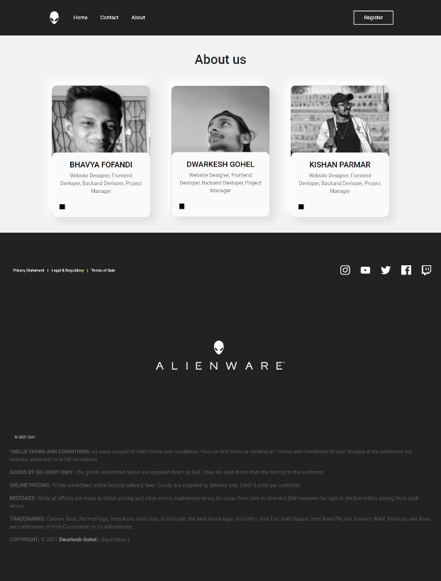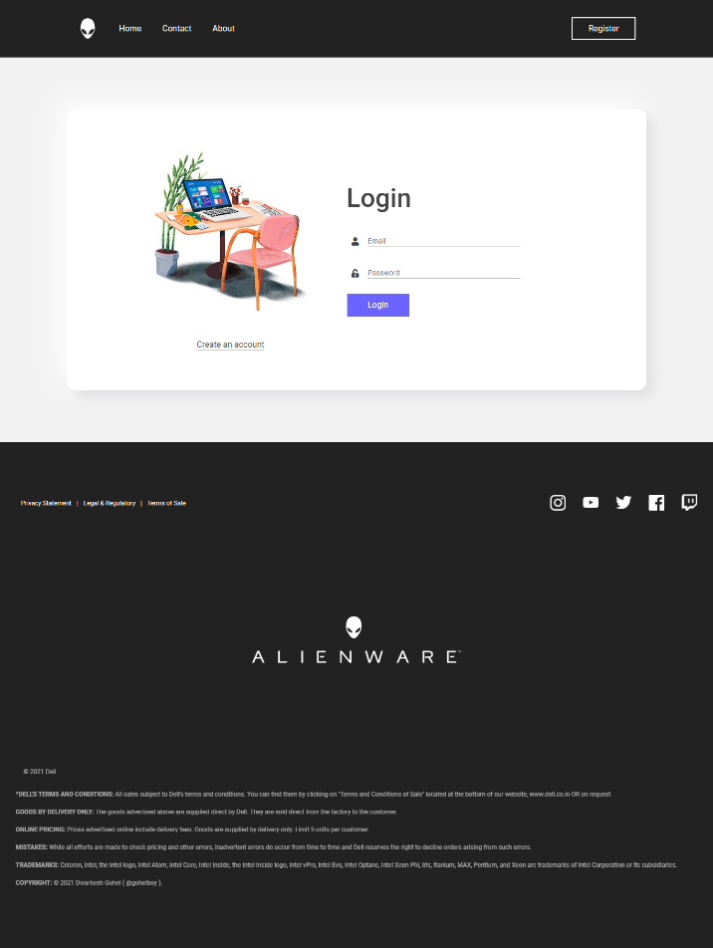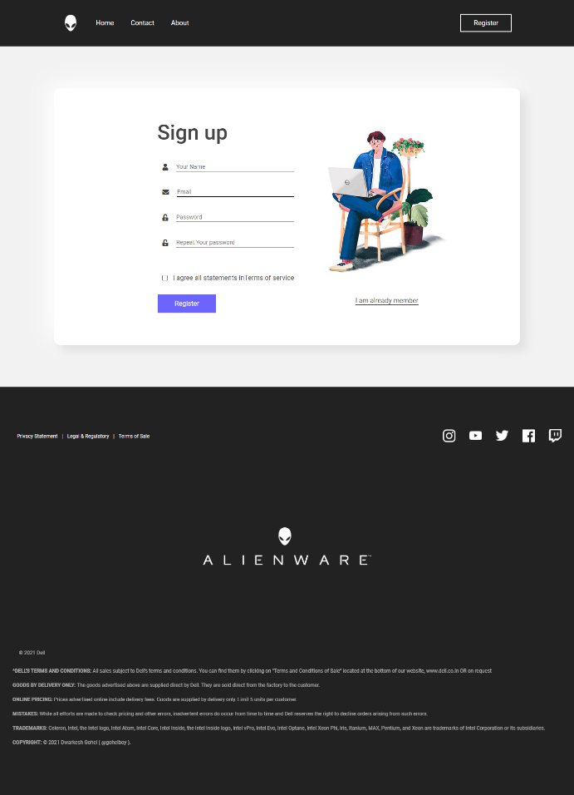

ABOUT PAGE CONTACT PAGE

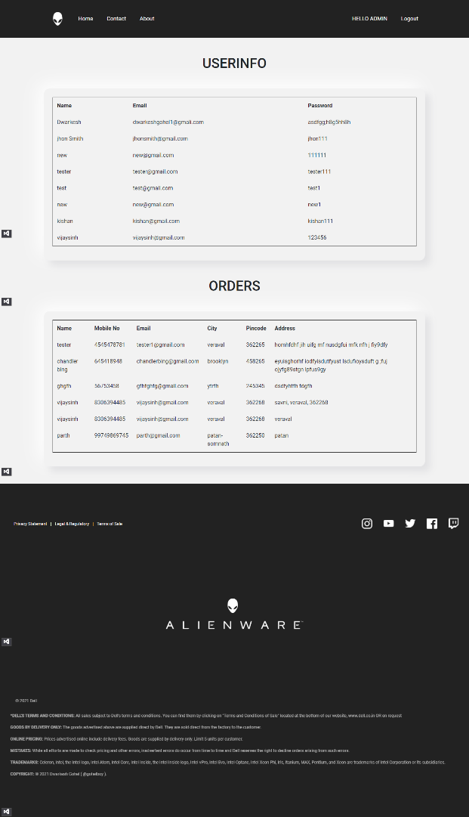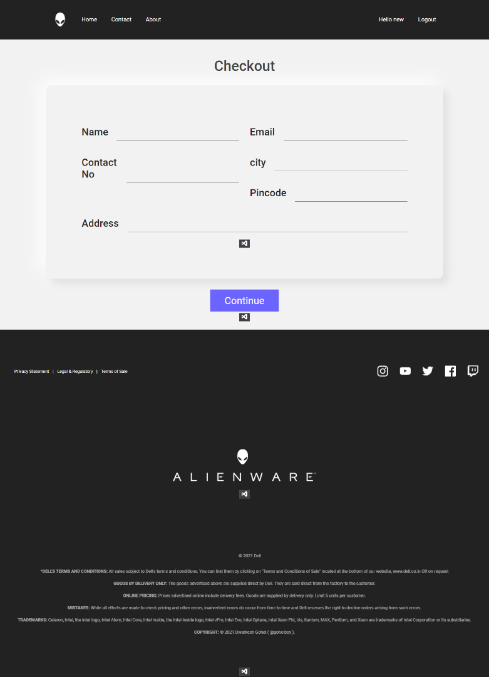

CHECKOUT PAGE USERDATA/ORDERS PAGE

.…………………………………………………………………………………………….

Coding

……………………………………………………………………………………………..

Master Page Code

<%@ Master Language="C#" AutoEventWireup="true" CodeBehind="AlienWare.master.cs" Inherits="AlienWare.AlienWare" %>

<!DOCTYPE html>

<html>

<head runat="server">

<title>Alienware</title>

<link rel = "icon" type = "image/png" href="Assets/LOGOS/aw-icon.png" />

<%--- BootStrap CSS ---%>

<link href="Bootstrap/css/bootstrap.min.css" rel="stylesheet" />

<%--- Fontawesome css ---%>

<link href="fontawesome/css/all.css" rel="stylesheet" />

<%--- Custom CSS ---%>

<link href="css/masterpage.css" rel="stylesheet" />

<%--- BootStrap JS ---%>

<script src="Bootstrap/js/jquery-3.5.1.slim.min.js"></script>

<script src="Bootstrap/js/popper.min.js"></script>

<script src="Bootstrap/js/bootstrap.min.js"></script>

<asp:ContentPlaceHolder ID="head" runat="server">

</asp:ContentPlaceHolder>

</head>

<body>

<form id="form1" runat="server">

<%--- Navbar ---%>

<nav class="nav">

<div class="container">

<div class="navlink">

<ul>

<li><a href="homepage.aspx"><img src="/Assets/LOGOS/aw-icon.png"/> </a></li>

<li><asp:LinkButton href="homepage.aspx" runat="server">Home</asp:LinkButton></li>

<li><asp:LinkButton href="contact.aspx" runat="server">Contact</asp:LinkButton></li>

<li><asp:LinkButton href="about.aspx" runat="server">About</asp:LinkButton></li>

</ul>

<div>

<ul>

<li><asp:LinkButton class="rbtn" ID="Register" href="signup.aspx" runat="server">Register</asp:LinkButton></li>

<li><asp:LinkButton ID="HELLO" runat="server"><span>Hello, USER</span></asp:LinkButton></li>

<li><asp:LinkButton ID="Logout" OnClick="Logout_Click" runat="server">Logout</asp:LinkButton></li>

</ul>

</div>

</div>

</div>

</nav>

<div>

<asp:ContentPlaceHolder ID="ContentPlaceHolder1" runat="server"></asp:ContentPlaceHolder>

</div>

<%--- Footer ---%>

<footer>

<div class="col-xl-12">

<div class="footer-links">

<div class="right-links">

<ul>

<li> <a href="#">Privacy Statement</a> </li> |

<li> <a href="#">Legal & Regulatory</a> </li> |

<li> <a href="#">Terms of Sale</a> </li>

</ul>

</div>

<div class="left-links">

<img src="/Assets/icon/icn-instagram@2x.png" />

<img src="/Assets/icon/icn-youtube@2x.png" />

<img src="/Assets/icon/icn-twitter@2x.png" />

<img src="/Assets/icon/icn-facebook@2x.png" />

<img src="/Assets/icon/icn-twitch@2x.png" />

</div>

</div>

</div>

<div class="col-xl-12"><div class="aw-brand"><img src="/Assets/LOGOS/Alienware.png" /></div></div>

<div class="col-xl-12">

<div class="last-section">

<div class="dell">

© 2021 Dell

</div>

<div class="legal">

<div >

<p><span>*DELL'S TERMS AND CONDITIONS: </span>All sales subject to Dell's terms and conditions. You can find them by clicking on "Terms and Conditions of Sale" located at the bottom of our website, www.dell.co.in OR on request</p>

<p><span>GOODS BY DELIVERY ONLY: </span>The goods advertised above are supplied direct by Dell. They are sold direct from the factory to the customer.</p>

<p><span>ONLINE PRICING: </span>Prices advertised online include delivery fees. Goods are supplied by delivery only. Limit 5 units per customer. </p>

<p><span>MISTAKES: </span>While all efforts are made to check pricing and other errors, inadvertent errors do occur from time to time and Dell reserves the right to decline orders arising from such errors.</p>

<p><span>TRADEMARKS: </span>Celeron, Intel, the Intel logo, Intel Atom, Intel Core, Intel Inside, the Intel Inside logo, Intel vPro, Intel Evo, Intel Optane, Intel Xeon Phi, Iris, Itanium, MAX, Pentium, and Xeon are trademarks of Intel Corporation or its subsidiaries.</p>

<p><span>COPYRIGHT: </span>© 2021 <a href="#">Dwarkesh Gohel</a> ( @gohelboy ).</p>

</div>

</div>

</div>

</div>

</footer>

</form>

</body>

</html>

Home Page Code

<%@ Page Title="" Language="C#" MasterPageFile="~/AlienWare.Master" AutoEventWireup="true" CodeBehind="homepage.aspx.cs" Inherits="AlienWare.WebPages.homepage" %>

<asp:Content ID="Content1" ContentPlaceHolderID="head" runat="server">

<link href="../css/homepage.css" rel="stylesheet" />

</asp:Content>

<asp:Content ID="Content2" ContentPlaceHolderID="ContentPlaceHolder1" runat="server">

<div class="light-bg-section">

<div class="container">

<div class="col-xl-12">

<div class="microinfo">

<div class="inteltext"><p>Intel® Core™<br />Processors</p></div>

<div class="intellogo"><p><img src="../Assets/LOGOS/family-core-i5i7i3-60h.PNG" /></p></div>

</div>

</div>

<div class="col-xl-12"><div class="title"><h1>ALIENWARE GAMING LAPTOPS</h1></div></div>

<div class="col-xl-12">

<div class="desc">

<h3>THIN OUT THE COMPETITION</h3>

<p>The incredibly thin design and unrelenting power of the Alienware m15 R3 and AREA-51M R2 laptops<br /> let you game like never before.</p>

<div class="haloimg"><img src="../Images/laptop%20halo.jpg" /></div>

</div>

</div>

</div>

</div>

<div class="slightwhite-bg-section">

<div class="container">

<div class="col-xl-12">

<div class="laptops-tabel"><h2>GAMING LAPTOPS</h2><h3>Laptops that take you deeper into the game.</h3></div>

</div>

<div class="col-xl-12">

<div class="compare-section">

<div class="compare-item">

<div class="pimg col-md-3"><img src="../Images/laptops.png" /></div>

<div class="pimg col-md-3"><img src="../Images/laptops.png" /></div>

<div class="pimg col-md-3"><img src="../Images/laptops.png" /></div>

<div class="pimg col-md-3"><img src="../Images/laptops.png" /></div>

</div>

<div class="compare-item">

<div class="col-md-3"><div class="p-title"><h2>NEW ALIENWARE M15 R3 GAMING</h2></div></div>

<div class="col-md-3"><div class="p-title"><h2>ALIENWARE M15 R2 GAMING<</h2></div></div>

<div class="col-md-3"><div class="p-title"><h2>NEW ALIENWARE-51M R2 GAMING</h2></div></div>

<div class="col-md-3"><div class="p-title"><h2>>ALIENWARE AREA 51M GAMING</h2></div></div>

</div>

<div class="specification-items">

<div>

<div class="col-md-3">

<div> Alienware’s most thin and powerful 38.1cm (15) laptop ever. Now with the option for up to 10th gen Intel® Core™ i9k processors with up to 12-phase HyperEfficient Voltage regulation. </div>

</div>

<div class="col-md-3">

<div> The all new Alienware m15 gaming laptop with hyper-efficient voltage regulation and new industrial ID.</div>

</div>

<div class="col-md-3">

<div> World's most powerful and overclockable gaming laptop with NVIDIA graphics. Featuring up to 10th Gen Intel® Core™ i9K processors.</div>

</div>

<div class="col-md-3">

<div> Revolutionary 17-inch gaming laptop with upgradeable, overclockable desktop 9th Gen Intel® Core™ processors and NVIDIA GPUs, plus a magnesium alloy chassis.</div>

</div>

</div>

<div>

<div class="col-md-3"><div>Up to Intel® Core™ i9-10980HK</div></div>

<div class="col-md-3"> <div> 10980HK Up to 9th Generation Intel® Core™ i9-9980HK (8-Core, 16MB Cache, up to 5.0Ghz w/Turbo Boost </div></div>

<div class="col-md-3"><div> 10th Generation Intel® Core™ i9-10900K </div> </div>

<div class="col-md-3"><div> Up to 9th Generation Intel® Core™ i9-9900K (8-Core, 16MB Cache, up to 5.0Ghz w/Turbo Boost) </div></div>

</div>

<div>

<div class="col-md-3"><div> Windows® 10 Home Plus Single Language </div> </div>

<div class="col-md-3"><div> Windows® 10 Home Plus Single Language </div></div>

<div class="col-md-3"><div> Windows® 10 Home Plus Single Language </div></div>

<div class="col-md-3"><div>Windows 10 Home Plus Single Language </div> </div>

</div>

<div>

<div class="col-md-3"><div> Up to 32GB RAM </div></div>

<div class="col-md-3"><div> Up to 16GB (2x8GB) DDR4 2666MHz </div> </div>

<div class="col-md-3"><div>32GB (2x16GB), XMP 3200MHz</div></div>

<div class="col-md-3"><div>Up to 32GB, 2x16GB, DDR4, 2400MHz</div></div>

</div>

<div>

<div class="col-md-3"><div>Up to 1TB M.2 PCIe NVMe SSD </div></div>

<div class="col-md-3"><div> Up to 1TB PCIe M.2 SSD</div></div>

<div class="col-md-3"><div>1TB NVMe M.2 SSD (Class 40)</div></div>

<div class="col-md-3"><div> Up to 1TB NVMe M.2 SSD (Class 40)</div></div>

</div>

<div>

<div class="col-md-3"><div>Up to NVIDIA® GeForce® RTX 2080 SUPER™ 8GB GDDR6 with Max-Q Design</div></div>

<div class="col-md-3"><div>Up to NVIDIA® GeForce RTX™ 2080 8GB GDDR6 with Max-Q Design </div></div>

<div class="col-md-3"><div>NVIDIA® GeForce® RTX 2080 with 8GB GDDR6</div></div>

<div class="col-md-3"><div>Up to NVIDIA® GeForce® RTX 2080 with 8GB GDDR6</div></div>

</div>

<div>

<div class="col-md-3"><div>15.6" OLED UHD 1ms 400-nits DCI-P3 color gamut + Tobii Eyetracking technology</div></div>

<div class="col-md-3"><div>T15.6" OLED UHD (3840 x 2160) 60Hz 1ms HDR-400 DCI-P3 color gamut + Tobii Eyetracking technology </div></div>

<div class="col-md-3"><div> 17.3" FHD 300Hz IPS 300nits with Tobii & non-GSYNC - Light </div></div>

<div class="col-md-3"><div>Up to 17.3" FHD (1920 x 1080) 144Hz, IPS, NVIDIA G-SYNC, Eyesafe® Display Tech + Tobii Eyetracking[GL85UVC]</div></div>

</div>

<div><div class="col-md-3"><div>Starting at ₹ 2,11,990.00</div></div></div>

</div>

</div>

</div>

</div>

</div>

<div class="light-bg-section">

<div class="container">

<div class="col-xl-12">

<div class="leftlaptopsection">

<div class="featured-image"><img src="../Images/laptop-back.png" /></div>

<div class="featured-title">

<h5>INNOVATIVE ENGINEERING</h5>

<p>The latest generation of Alienware laptops with our Legend Industrial Design feature an improved surface coating engineered to reduce fingerprint smears and stains without changing the hue or color.</p>

</div>

</div>

</div>

</div>

</div>

<div class="dark-bg-section">

<div class="container">

<div class="col-xl-12">

<div class="rightlaptopsection1">

<div class="featured-title-dark">

<h3>PREPARE YOUR GAMING PC FOR BATTLE</h3>

<p>Battle the game, not your PC. With Premium Support Plus, your hardware will perform at its best, your games will be more responsive, and you'll be unbeatable. It's Dell’s ultimate support for gaming PCs.*</p>

<asp:Button ID="tobuypage" class="button" OnClick="tobuypage_Click" runat="server" Text="Learn more"></asp:Button>

</div>

<div class="featured-image-dark"><img src="../Images/awarea-51mnt_nontobii_lnb_00055rf110_gy.png" /></div>

</div>

<div class="col-xl-12">

<div class="rightlaptopsection1">

<div class="featured-title-dark">

<h3>LEADING DESIGN & FUNCTION</h3>

<p>Every Alienware laptop is crafted with magnesium alloy for a durable, elite feel that’s effortlessly mobile. The four-zone, multi-color RGB keyboard offers you total AlienFX control and programmable keys.</p>

</div>

<div class="featured-image-dark"><img src="../Images/part.png" /></div>

</div>

</div>

</div>

</div>

</div>

<div class="slightwhite-bg-section">

<div class="container">

<div class="col-xl-12">

<div class="partlaptop">

<div class="featured-title-white">

<h3>GAMING IN THE 4K REALM</h3>

<p>Connect your Alienware laptop or Alpha to the Graphics Amplifier to unlock new levels of intensity. Get lost in the desktop-class graphics or go further with full VR immersion.</p>

</div>

<div class="featured-image-dark"><img src="../Images/Gaming%204K%20Realm.png" /></div>

</div>

</div>

</div>

</div>

</asp:Content>

## SIGNUP PAGE

<%@ Page Title="" Language="C#" MasterPageFile="~/AlienWare.Master" AutoEventWireup="true" CodeBehind="signup.aspx.cs" Inherits="AlienWare.WebPages.signup" %>

<asp:Content ID="Content1" ContentPlaceHolderID="head" runat="server">

<link href="../css/signup.css" rel="stylesheet" />

</asp:Content>

<asp:Content ID="Content2" ContentPlaceHolderID="ContentPlaceHolder1" runat="server">

<div class="signup-main">

<div class="col-xl-12">

<div class="container">

<div class="form-holder">

<div class="signup-form">

<h1>Sign up</h1>

<div class="form-group">

<i class="fa fa-user" aria-hidden="true"></i>

<asp:RequiredFieldValidator ID="RequiredFieldValidator1" runat="server" ErrorMessage="*" ForeColor="Red" ControlToValidate="name"></asp:RequiredFieldValidator>

<asp:TextBox ID="name" class="tf" runat="server" TextMode="SingleLine" placeholder="Your Name" MaxLength="20" autocomplete="off"></asp:TextBox>

</div>

<div class="form-group">

<i class="fa fa-envelope" aria-hidden="true"></i>

<asp:RequiredFieldValidator ID="RequiredFieldValidator2" runat="server" ErrorMessage="*" ForeColor="Red" ControlToValidate="email"></asp:RequiredFieldValidator>

<asp:TextBox ID="email" class="tf" runat="server" TextMode="Email" placeholder="Email" autocomplete="off"></asp:TextBox>

</div>

<div class="form-group">

<i class="fa fa-unlock-alt" aria-hidden="true"></i>

<asp:RequiredFieldValidator ID="RequiredFieldValidator3" runat="server" ErrorMessage="*" ForeColor="Red" ControlToValidate="password"></asp:RequiredFieldValidator>

<asp:TextBox ID="password" class="tf" runat="server" TextMode="Password" placeholder="Password" ControlToCompare="password"></asp:TextBox>

</div>

<div class="form-group">

<i class="fa fa-unlock-alt" aria-hidden="true"></i>

<asp:RequiredFieldValidator ID="RequiredFieldValidator4" runat="server" ErrorMessage="*" ForeColor="Red" ControlToValidate="repassword"></asp:RequiredFieldValidator>

<asp:TextBox ID="repassword" class="tf" runat="server" TextMode="Password" placeholder="Repeat Your password"></asp:TextBox>

</div>

<asp:CompareValidator ID="CompareValidator1" runat="server" ErrorMessage="Enter Same Password" ControlToCompare="password" ControlToValidate="repassword" ForeColor="Red"></asp:CompareValidator>

<div class="form-group">

<asp:CheckBox ID="TC" class="fa" runat="server" /> I agree all statements in <span>Terms of service</span>

</div>

<div class="btn"><asp:Button ID="signupbtn" OnClick="signupbtn_Click" class="button" runat="server" Text="Register"></asp:Button></div>

</div>

<div class="img"><img src="../Images/signup-image.jpg" /><div class="loginlink"><a href="login.aspx">I am already member</a></div></div>

</div>

</div>

</div>

</div>

</asp:Content>

## LOGIN PAGE

<%@ Page Title="" Language="C#" MasterPageFile="~/AlienWare.Master" AutoEventWireup="true" CodeBehind="login.aspx.cs" Inherits="AlienWare.WebPages.login" %>

<asp:Content ID="Content1" ContentPlaceHolderID="head" runat="server">

<link href="../css/login.css" rel="stylesheet" />

</asp:Content>

<asp:Content ID="Content2" ContentPlaceHolderID="ContentPlaceHolder1" runat="server">

<div class="login-main">

<div class="col-xl-12">

<div class="container">

<div class="form-holder">

<div class="img"><img src="../Images/login-image.jpg" /><div class="loginlink"><a href="signup.aspx">Create an account</a></div></div>

<div class="login-form">

<h1>Login</h1>

<div class="form-group">

<i class="fa fa-user" aria-hidden="true"></i>

<asp:RequiredFieldValidator ID="RequiredFieldValidator1" runat="server" ErrorMessage="*" ForeColor="Red" ControlToValidate="email"></asp:RequiredFieldValidator>

<asp:TextBox ID="email" class="tf" runat="server" TextMode="Email" placeholder="Email" autocomplete="off"></asp:TextBox>

</div>

<div class="form-group">

<i class="fa fa-unlock-alt" aria-hidden="true"></i>

<asp:RequiredFieldValidator ID="RequiredFieldValidator2" runat="server" ErrorMessage="*" ForeColor="Red" ControlToValidate="password"></asp:RequiredFieldValidator>

<asp:TextBox ID="password" class="tf" runat="server" TextMode="Password" placeholder="Password"></asp:TextBox>

</div>

<div class="btn"><asp:Button ID="loginbtn" class="button" OnClick="loginbtn_Click" runat="server" Text="Login"></asp:Button></div>

</div>

</div>

</div>

</div>

</div>

</asp:Content>

## ABOUT US

<%@ Page Title="" Language="C#" MasterPageFile="~/AlienWare.Master" AutoEventWireup="true" CodeBehind="about.aspx.cs" Inherits="AlienWare.WebPages.about" %>

<asp:Content ID="Content1" ContentPlaceHolderID="head" runat="server">

<link href="../css/about.css" rel="stylesheet" />

</asp:Content>

<asp:Content ID="Content2" ContentPlaceHolderID="ContentPlaceHolder1" runat="server">

<div class="about">

<div class="container">

<h1> About us </h1>

<div class="about-box">

<div class="card">

<div class="image"><img src="../Images/IMG_20190102_111030%20(2).jpg" /></div>

<div class="desc"><h5>BHAVYA FOFANDI</h5><p>Website Designer, Frontend Devloper, Backand Devloper, Project Manager</p></div>

<a href="#"><div class="property-social-icons"></div></a>

</div>

<div class="card">

<div class="image">

<img src="../Images/me%20(2).jpg" />

</div>

<div class="desc"><h5>DWARKESH GOHEL</h5><p>Website Designer, Frontend Devloper, Backand Devloper, Project Manager</p></div>

<a href="#"><div class="property-social-icons"></div></a>

</div>

<div class="card">

<div class="image"><img src="../Images/kd.JPG" /></div>

<div class="desc"><h5>KISHAN PARMAR</h5><p>Website Designer, Frontend Devloper, Backand Devloper, Project Manager</p></div>

<a href="#"><div class="property-social-icons"></div></a>

</div>

</div>

</div>

</div>

</asp:Content>

## CONTACT US

<%@ Page Title="" Language="C#" MasterPageFile="~/AlienWare.Master" AutoEventWireup="true" CodeBehind="contact.aspx.cs" Inherits="AlienWare.WebPages.contact" %>

<asp:Content ID="Content1" ContentPlaceHolderID="head" runat="server">

<link href="../css/contact.css" rel="stylesheet" />

</asp:Content>

<asp:Content ID="Content2" ContentPlaceHolderID="ContentPlaceHolder1" runat="server">

<div class="contact">

<div class="container">

<div class="title"><h1>Contact Information</h1></div>

<div class="contact-box row">

<div class="col-lg-4">

<div class="disc-title"><h3>Technical Support</h3></div>

<div class="desc-text"><p>Troubleshoot and fix issues with your Dell or Dell EMC product or check the status of open dispatches. Identify your system to see all available contact options, including Service Requests, Email, Chat, and Phone</p></div>

</div>

<div class="col-lg-4">

<div class="disc-title"><h3>Order Suppoort</h3></div>

<div class="desc-text"><p>Get help after purchasing: inquire about order status, delivery, returns, invoices, or other order-related issues.</p></div>

</div>

<div class="col-lg-4">

<div class="disc-title"><h3>Sales</h3></div>

<div class="desc-text"><p>Get help before purchasing or make a purchase: interact with Dell sales to match your needs with the right products.</p></div>

</div>

<div class="col-lg-4">

<div class="disc-title"><h3>international Sipport Serviece</h3></div>

<div class="desc-text"><p>Find all the contact options when you travel with your Dell products outside your home country. Diagnose and resolve technical problems or arrange Next Business Day On-Site Service over the phone when traveling internationally.</p></div>

</div>

<div class="col-lg-4">

<div class="disc-title"><h3>Administrative Support</h3></div>

<div class="desc-text"><p>Obtain non-technical support for licensing, warranty, online account and other types of administrative help for your Dell EMC products. If you need assistance with a Dell product (monitor, laptop, server, etc) please select Technical Support.</p></div>

</div>

<div class="col-lg-4">

<div class="disc-title"><h3>Carry In serviece Center</h3></div>

<div class="desc-text"><p>Choose your Dell authorized Carry In Service centers near you.<br />Your complete satisfaction is our goal.</p></div>

</div>

<div class="col-lg-4">

<div class="disc-title"><h3>Partner Support</h3></div>

<div class="desc-text"><p>Create support cases to get answers to questions, such as: Ordering, Account Management, Partner Training, Marketing & Sales tools and Partner Program & Communications.</p></div>

</div>

</div>

</div>

</div>

</asp:Content>

## CHECK OUT

<%@ Page Title="" Language="C#" MasterPageFile="~/AlienWare.Master" AutoEventWireup="true" CodeBehind="checkout.aspx.cs" Inherits="AlienWare.WebPages.checkout" %>

<asp:Content ID="Content1" ContentPlaceHolderID="head" runat="server">

<link href="../css/checkout.css" rel="stylesheet" />

</asp:Content>

<asp:Content ID="Content2" ContentPlaceHolderID="ContentPlaceHolder1" runat="server">

<div class="main-checkout">

<div class="col-xl-12">

<div class="container">

<h1>Checkout</h1>

<div class="box">

<div class="row">

<div class="col-lg-6">

<div class="form-group">

<h3>Name</h3>

<asp:TextBox ID="name" class="tf" TextMode="SingleLine" autocomplete="off" runat="server"></asp:TextBox>

</div>

<div class="form-group">

<h3>Contact No</h3>

<asp:TextBox ID="contactno" class="tf" TextMode="Number" autocomplete="off" runat="server"></asp:TextBox>

</div>

</div>

<div class="col-lg-6">

<div class="form-group">

<h3>Email</h3>

<asp:TextBox ID="email" class="tf" TextMode="Email" autocomplete="off" runat="server"></asp:TextBox>

</div>

<div class="form-group">

<h3>city</h3>

<asp:TextBox ID="city" class="tf" TextMode="SingleLine" autocomplete="off" runat="server"></asp:TextBox>

</div>

<div class="form-group">

<h3>Pincode</h3>

<asp:TextBox ID="pincode" class="tf" TextMode="Number" autocomplete="off" runat="server"></asp:TextBox>

</div>

</div>

<div class="col-lg-12">

<div class="form-group">

<h3>Address</h3>

<asp:TextBox ID="address" class="tf" runat="server"></asp:TextBox>

</div>

</div>

</div>

</div>

<asp:Button ID="orderbtn" class="orderbtn" OnClick="orderbtn_Click" runat="server" Text="Continue" />

</div>

</div>

</div>

</asp:Content>

## ADMIN_SIDE

<%@ Page Title="" Language="C#" MasterPageFile="~/AlienWare.Master" AutoEventWireup="true" CodeBehind="admin-section.aspx.cs" Inherits="AlienWare.WebPages.admin_section" %>

<asp:Content ID="Content1" ContentPlaceHolderID="head" runat="server">

<link href="../css/admin-section.css" rel="stylesheet" />

<link href="../Datatable/css/jquery.dataTables.min.css" rel="stylesheet" />

</asp:Content>

<asp:Content ID="Content2" ContentPlaceHolderID="ContentPlaceHolder1" runat="server">

<div class="main-admin-section">

<div class="col-xl-12">

<div class="container">

<div class="datatable">

<h1>USERINFO</h1>

<div class="tables">

<asp:SqlDataSource ID="SqlDataSource1" runat="server" ConnectionString="<%$ ConnectionStrings:databaseConnectionString %>" SelectCommand="SELECT * FROM [userinfo]"></asp:SqlDataSource>

<asp:GridView ID="GridView1" class="datas table table-borderless table-responsive-xl" runat="server" DataSourceID="SqlDataSource1"></asp:GridView>

</div>

</div>

<h1>ORDERS</h1>

<div class="orders">

<asp:SqlDataSource ID="SqlDataSource2" runat="server" ConnectionString="<%$ ConnectionStrings:databaseConnectionString %>" SelectCommand="SELECT * FROM [orders]"></asp:SqlDataSource>

<asp:GridView ID="GridView2" class="datas table table-borderless table-responsive-xl" runat="server" DataSourceID="SqlDataSource2" AutoGenerateColumns="False">

<Columns>

<asp:BoundField DataField="Name" HeaderText="Name" SortExpression="Name" />

<asp:BoundField DataField="Mobile_No" HeaderText="Mobile No" SortExpression="Mobile No" />

<asp:BoundField DataField="Email" HeaderText="Email" SortExpression="Email" />

<asp:BoundField DataField="City" HeaderText="City" SortExpression="City" />

<asp:BoundField DataField="Pincode" HeaderText="Pincode" SortExpression="Pincode" />

<asp:BoundField DataField="Address" HeaderText="Address" SortExpression="Address" />

</Columns>

</asp:GridView>

</div>

</div>

</div>

</div>

</asp:Content>

## PRODUCT PAGE

<%@ Page Title="" Language="C#" MasterPageFile="~/AlienWare.Master" AutoEventWireup="true" CodeBehind="alienware-area51m-r2-laptop.aspx.cs" Inherits="AlienWare.WebPages.alienware_area51m_r2_laptop" %>

<asp:Content ID="Content1" ContentPlaceHolderID="head" runat="server">

<link href="../css/alienware-area51m-r2-laptop.css" rel="stylesheet" />

</asp:Content>

<asp:Content ID="Content2" ContentPlaceHolderID="ContentPlaceHolder1" runat="server">

<div class="alienware-area51m-r2-laptop">

<div class="col-xl-12">

<div class="container">

<div class="microinfo">

<div class="inteltext"><p>Intel® Core™<br />Processors</p></div>

<div class="intellogo"><p><img src="../Assets/LOGOS/family-core-i5i7i3-60h.PNG" /></p></div>

</div>

</div>

<div class="main-canvas">

<div class="hero container">

<div class="col-xl-12">

<div class="hero-wrap">

<div class="hero-right-side">

<div class="product">

<div class="big-img-container"><img ID="imagebox" src="../Images/aw-1.jpg"/></div>

<div class="small-img">

<img src="../Images/aw-1.jpg" onclick="myFunction(this)"/>

<img src="../Images/aw-2.jpg" onclick="myFunction(this)"/>

<img src="../Images/aw-3.jpg" onclick="myFunction(this)"/>

<img src="../Images/aw-4.jpg" onclick="myFunction(this)"/>

</div>

</div>

</div>

<div class="hero-left-side"">

<div class="hero-title"><img src="../Assets/LOGOS/aw-icon-dark.png" /><h1>ALIENWARE AREA-51M R2 GAMING LAPTOP</h1></div>

<div class="hero-content">

<div class="hero-detail">

<h2>DESKTOP IN DISGUISE</h2>

<p>World's most powerful and overclockable gaming laptop with NVIDIA graphics. Featuring up to 10th Gen Intel® Core™ i9K processors.</p>

<p class="hero-price"> Rs. 2,30,100 </p>

<asp:Button ID="buybtn" class="button" OnClick="buybtn_Click" runat="server" Text="BUY NOW" />

</div>

</div>

</div>

</div>

</div>

</div>

</div>

</div>

<div class="col-xl-12"><div class="container"><div class="specs-title"><h1>PRODUCT DETAILS</h1></div></div></div>

<div class="specs">

<div class="col-xl-12">

<div class="container">

<div class="specs1">

<div class="os">

<div class="content">

<h2>OPERATING SYSTEM</h2>

<p><span>Available with Windows 10 Home:</span> Gaming is better than ever on Windows 10, with games in DirectX 12, and streaming your gameplay.*</p>

</div>

<img src="../Images/specs-1.jpg" />

</div>

</div>

</div>

</div>

<div class="col-xl-12">

<div class="container">

<div class="specs1">

<div class="os">

<div class="content">

<h2>BREAKING NEW BENCHMARKS. AGAIN.</h2>

<p>Our most powerful laptop just got an upgrade. With extraordinary desktop-level processing power, CPU and GPU upgradability, advanced cooling and a premium, revolutionary design, the Alienware Area-51m R2 is a true desktop-gaming experience in the form of a laptop.</p>

</div>

<img src="../Images/specs-2.jpg" />

</div>

</div>

</div>

</div>

<div class="col-xl-12">

<div class="container">

<div class="specs1">

<div class="os">

<div class="content">

<h2>UNPRECEDENTED POWER & PERFORMANCE</h2>

<p><span>New firsts in power:</span> The Area-51m R2 features a host of firsts for peak performance and power. It’s our first-ever laptop to feature overclockable 10th Gen Intel® Core™ i9K desktop processors, support for up to 125W of power, and 10-core desktop CPU options, giving it a whole new level of compute power versus other gaming laptops.</p>

<p><span>Greater graphics and gameplay:</span> Experience vivid, uninterrupted gaming and faster frame rates during high-powered gameplay thanks to overclockable NVIDIA® GeForce RTX™ graphics. Now featuring a new 360Hz FHD display option, you can expect the smoothest fast-paced gameplay and the best 43.18 cm front-of-screen experience imaginable.</p>

<p><span>Massive memory:</span> With support for up to 32GB of DDR4 memory, there’s enough RAM for even the most resource-intensive workloads and tasks, making the Area-51m R2 ideal for gaming developers, content creators and megatasking streamers.</p>

</div>

<img src="../Images/specs-3.jpg" />

</div>

</div>

</div>

</div>

<div class="col-xl-12">

<div class="container">

<div class="specs1">

<div class="os">

<div class="content">

<h2>ADVANCED COOLING & PERFORMANCE UPDATES</h2>

<p>The Area-51m R2 features all-new engineering efforts to increase thermal capacity and performance. It now offers three different cooling solutions and power management techniques based on your graphics selection. Every one of these new features is engineered to enable the higher wattage requirements of our new updates and their respective overclocking expectations.</p>

<p><span>Hyper-efficient voltage regulation</span> is a technology developed by the Alienware engineering team to enable maximum performance for extended amounts of time with safeguarded thermal conditions. For the first time ever in a gaming laptop, the Area-51m R2 features a 12-phase graphics voltage regulation option on NVIDIA® GeForce® RTX 2080 SUPER™, ensuring Alienware’s highest sustained graphics performance ever.</p>

<p><span>Vapor chamber cooling technology</span> uses advanced methods to efficiently dissipate heat from extreme-performance graphics options. These chambers utilize the phase-changing nature of liquid to transfer heat more effectively than a solid piece of metal or copper heat pipes. Vapor chambers are also more versatile than copper heat pipes in that they can be spread evenly across an entire chip that needs to be cooled.</p>

<p><span>10% larger fan blades</span> than the previous generation of the Area-51m R2 are available on both NVIDIA® GeForce® RTX 2070 SUPER™ and 2080 SUPER™ options, ensuring high-performance graphics cards receive enhanced cooling when the action heats up.</p>

</div>

<img src="../Images/specs-4.jpg" />

</div>

</div>

</div>

</div>

<div class="col-xl-12">

<div class="container">

<div class="specs1">

<div class="os">

<div class="content">

<h2>ICONIC DESIGN WITH A MODERN EDGE</h2>

<p>The Alienware Area-51m R2 raises the bar for innovative engineering with its game-changing design. The visual identity was inspired by our early industrial designs, marking a return to form while taking cues from our original roots.</p>

<p>The futuristic design of the Area-51m R2 reflects the diverse, evolving nature of gamers everywhere, incorporating high contrast, performance-focused engineering with blended bone lines, angled sections, bold lighting, and celebrated thermals.</p>

<p><span>Bold lighting:</span> The latest evolution of AlienFX lighting features a striking ring of light at the rear of the system, highlighting system performance while maintaining ultimate customizability.</p>

<p><span>Narrow bezel:</span> The Area-51m R2 features a drastic reduction of screen borders thanks to its narrow bezel with a three-knuckle hinge. This reduces the mass and maintains a strong connection to the base.</p>

<p><span>Premium shell:</span> The unique magnesium alloy exoskeleton enables enhanced rigidity, while reducing overall chassis weight. This allows more space for high-performance components inside the machine.</p>

<p><span>Dual color options</span>: Gamers can choose between a new, futuristic look in Lunar Light or Dark Side of the Moon, a darker, more traditional appearance.</p>

</div>

<img src="../Images/specs-5.jpg" />

</div>

</div>

</div>

</div>

<div class="col-xl-12">

<div class="container">

<div class="specs1">

<div class="os">

<div class="content">

<h2>GAME-ENHANCING FEATURES</h2>

<p><span>Advanced keyboard:</span> Alienware keyboard with N-key rollover technology enables over 103-key commands for maximum actions per minute and 1.7mm of key travel allows for rapid response for any keystroke. Per-key AlienFX lighting delivers customizable lighting profiles, while programmable macro keys let you create gaming and non-gaming shortcuts for over 150 game titles.</p>

<p><span>2.5Gbps Killer Ethernet:</span> The Area-51m R2 features up to 2.5Gbps of bandwidth over a Killer E3000 Ethernet port providing gamers up to 2.5x the amount of bandwidth available in common, wired Ethernet, connections for blazing-fast file transfers.</p>

<p><span>Thunderbolt™ Type-C port:</span> This multi-use port is ready to be used as a USB 3.1 port, offering 10Gbps of data transfer, a Thunderbolt™ connection capable of 40Gbps, or even a DisplayPort enabling various monitors supporting the DisplayPort protocol</p>

<p><span>Enhanced storage:</span> The Area-51m R2 offers single storage drive option of 1TB M.2 PCIe NVMe SSD for additional storage and giving you added performance.</p>

<p><span>Hear every battle cry:</span> Experience every sound with best-in-class speakers for a laptop. High-end headphone support delivers outstanding fidelity while Far Field Audio improves microphone performance.</p>

</div>

</div>

</div>

</div>

</div>

</div>

<div class="col-xl-12">

<div class="container">

<div class="back-btn"><asp:Button ID="tohomepage" class="button" runat="server" Text=" < Back " OnClick="tohomepage_Click"/></div>

</div>

</div>

</div>

<script>

function myFunction(smallimg) {

var fullimg = document.getElementById("imagebox");

fullimg.src = smallimg.src;

}

</script>

</asp:Content>

## CODE BEHIND FILE (master page)

using System;

using System.Collections.Generic;

using System.Linq;

using System.Web;

using System.Web.UI;

using System.Web.UI.WebControls;

namespace AlienWare

{

public partial class AlienWare : System.Web.UI.MasterPage

{

protected void Page_Load(object sender, EventArgs e)

{

if (string.IsNullOrEmpty((string)Session["user"]))

{

Register.Visible = true;

Logout.Visible = false;

HELLO.Visible = false;

}

else if (Session["user"].Equals("user"))

{

Register.Visible = false;

Logout.Visible = true;

HELLO.Visible = true;

HELLO.Text = "Hello " + Session["name"].ToString();

}

else if (Session["user"].Equals("Admin"))

{

Register.Visible = false;

Logout.Visible = true;

HELLO.Visible = true;

HELLO.Text = "HELLO ADMIN" ;

}

}

protected void Logout_Click(object sender, EventArgs e)

{

Session["user"] = "";

Session["name"] = "";

Register.Visible = true;

Logout.Visible = false;

HELLO.Visible = false;

}

}

}

## CODE BEHIND FILE (signup page)

using System;

using System.Configuration;

using System.Data.SqlClient;

using System.Data;

using System.Collections.Generic;

using System.Linq;

using System.Web;

using System.Web.UI;

using System.Web.UI.WebControls;

namespace AlienWare.WebPages

{

public partial class signup : System.Web.UI.Page

{

SqlConnection con = new SqlConnection(@"Data Source=(LocalDB)\MSSQLLocalDB;Initial Catalog=database;Integrated Security=True;Pooling=False");

protected void Page_Load(object sender, EventArgs e)

{

}

protected void signupbtn_Click(object sender, EventArgs e)

{

do_signup();

}

void do_signup()

{

try

{

if (con.State == ConnectionState.Closed || con.State == ConnectionState.Broken)

{

con.Open();

}

SqlCommand cmd = new SqlCommand("INSERT INTO userinfo (Name,Email,Password) values(@name, @email, @password)", con);

cmd.Parameters.AddWithValue("@name", name.Text.Trim());

cmd.Parameters.AddWithValue("@email", email.Text.Trim());

cmd.Parameters.AddWithValue("@password", password.Text.Trim());

cmd.ExecuteNonQuery();

con.Close();

name.Text = "";

email.Text = "";

password.Text = "";

repassword.Text = "";

Response.Write("<script>alert('Login to Your Account');</script>");

}

catch (Exception ex)

{

Response.Write("<script>alert('" + ex.Message + "')</script>");

}

}

}

}

## CODE BEHIND FILE (Login page)

using System;

using System.Data;

using System.Data.SqlClient;

using System.Collections.Generic;

using System.Linq;

using System.Web;

using System.Web.UI;

using System.Web.UI.WebControls;

namespace AlienWare.WebPages

{

public partial class login : System.Web.UI.Page

{

SqlConnection con = new SqlConnection(@"Data Source=(LocalDB)\MSSQLLocalDB;Initial Catalog=database;Integrated Security=True;Pooling=False");

protected void Page_Load(object sender, EventArgs e)

{

}

protected void loginbtn_Click(object sender, EventArgs e)

{

if(email.Text == "admin@gmail.com" && password.Text == "admin")

{

Session["user"] = "Admin";

Response.Redirect("/WebPages/admin-section.aspx");

}

else

{

do_login();

}

return;

}

void do_login()

{

try

{

if (con.State == ConnectionState.Closed || con.State == ConnectionState.Broken)

{

con.Open();

SqlCommand cmd = new SqlCommand("select * from userinfo where Email='" + email.Text.Trim() + "'AND Password='" + password.Text.Trim() + "'", con);

SqlDataReader dr = cmd.ExecuteReader();

if (dr.HasRows)

{

while (dr.Read())

{

Response.Write("<script>alert('LOGIN DONE');</script>");

Session["name"] = dr.GetValue(0).ToString();

Session["user"] = "user";

}

Response.Redirect("/WebPages/homepage.aspx");

}

else

{

Response.Write("<script>alert('Invalid username or password');</script>");

}

email.Text = "";

password.Text = "";

}

}

catch(Exception ex)

{

Response.Write("<script>alert('" + ex.Message + "')</script>");

}

}

}

}

## CODE BEHIND FILE (product page)

using System;

using System.Collections.Generic;

using System.Linq;

using System.Web;

using System.Web.UI;

using System.Web.UI.WebControls;

namespace AlienWare.WebPages

{

public partial class alienware_area51m_r2_laptop : System.Web.UI.Page

{

protected void Page_Load(object sender, EventArgs e)

{

}

protected void tohomepage_Click(object sender, EventArgs e)

{

Response.Redirect("/WebPages/homepage.aspx");

}

protected void buybtn_Click(object sender, EventArgs e)

{

if(Session["user"] == "user")

{

Response.Redirect("/WebPages/checkout.aspx");

}

else

{

Response.Redirect("/WebPages/login.aspx");

}

}

}

}

## CODE BEHIND FILE (checkout page)

using System;

using System.Data.SqlClient;

using System.Data;

using System.Collections.Generic;

using System.Linq;

using System.Web;

using System.Web.UI;

using System.Web.UI.WebControls;

namespace AlienWare.WebPages

{

public partial class checkout : System.Web.UI.Page

{

SqlConnection con = new SqlConnection(@"Data Source=(LocalDB)\MSSQLLocalDB;Initial Catalog=database;Integrated Security=True;Pooling=False");

protected void Page_Load(object sender, EventArgs e)

{

}

protected void orderbtn_Click(object sender, EventArgs e)

{

order();

}

void order()

{

try

{

if (con.State == ConnectionState.Closed || con.State == ConnectionState.Broken)

{

con.Open();

}

SqlCommand cmd = new SqlCommand("INSERT INTO orders (Name,Mobile_No,Email,City,Pincode,Address) values(@name, @contactno, @email, @city, @pincode, @address)", con);

cmd.Parameters.AddWithValue("@name", name.Text.Trim());

cmd.Parameters.AddWithValue("@contactno", contactno.Text.Trim());

cmd.Parameters.AddWithValue("@email", email.Text.Trim());

cmd.Parameters.AddWithValue("@city", city.Text.Trim());

cmd.Parameters.AddWithValue("@pincode", pincode.Text.Trim());

cmd.Parameters.AddWithValue("@address", address.Text.Trim());

cmd.ExecuteNonQuery();

con.Close();

name.Text = "";

contactno.Text = "";

email.Text = "";

city.Text = "";

pincode.Text = "";

address.Text = "";

Response.Write("<script>alert('Your Order Successfull');</script>");

Response.Redirect("/WebPages/homepage.aspx");

}

catch (Exception ex)

{

Response.Write("<script>alert('" + ex.Message + "')</script>");

}

}

}

}

## CODE BEHIND FILE (Admin page)

using System;

using System.Data.SqlClient;

using System.Data;

using System.Collections.Generic;

using System.Linq;

using System.Web;

using System.Web.UI;

using System.Web.UI.WebControls;

namespace AlienWare.WebPages

{

public partial class admin_section : System.Web.UI.Page

{

protected void Page_Load(object sender, EventArgs e)

{

SqlConnection con = new SqlConnection(@"Data Source = (LocalDB)\MSSQLLocalDB; Initial Catalog = database; Integrated Security = True; Pooling = False");

if (con.State == ConnectionState.Closed)

{

con.Open();

}

SqlCommand cmd = new SqlCommand(" DELETE from userinfo WHERE Email='' ", con);

cmd.ExecuteNonQuery();

con.Close();

}

}

}

Data Flow Diagram

### It is a graphical representation of the data. It identifies the path the data will take what process will take place to it from to another.

A DFD is a graphical representation of the flow of data through an information system. It can be used to provide a clear representation of any function. There for it is different from a flowchart.

Data Flow Diagram are composed of the four basic symbols shown below.

* The external entity symbol represents source of data to the system or destinations of data from the system.
* The Data Flow symbol repesents movement of data.
* The Data Store symbol represents data that is not moving (delayed data at rest).
* The Process symbol represents an activity that transforms or manipulates the data (combines, reorders, converts, etc.).
* Any system can be represented at any level of details by these four symbols.

⇨ Data flow 0 and 1 on Login for user

0 Level Diagram

Input

Verify

Home Page

User Credential

User

Confirm

Display

1st Level Diagram

Recovery/R

evert

aspect

No

Verify

User Credential

User

Username security

password

Login

*Yes*

*Reg database*

### ⇨ Dataflow 0 and 1 on Online Purchase and Sales System.

0 Level Diagram

Inquiry Order creative

The

Portal

Receipt/Payment

Customer

Invoice Payment

1st Level Diagram

z

Inquire

Login

Selling ref.

Verify

Payment

Confirm

Customer

Customer

booking db

ER Diagram

⇨ Login Page

Login

Check

Validation

Registration Page

User Home Page

⇨ Registration Page

Login

Despature_ Date

Reset

Registration

Booking_ date

User_Id

No_of_ adult

Room_typ e

Email_ID

User

User_name Address State

Submit

Mobile no

Pin code

city

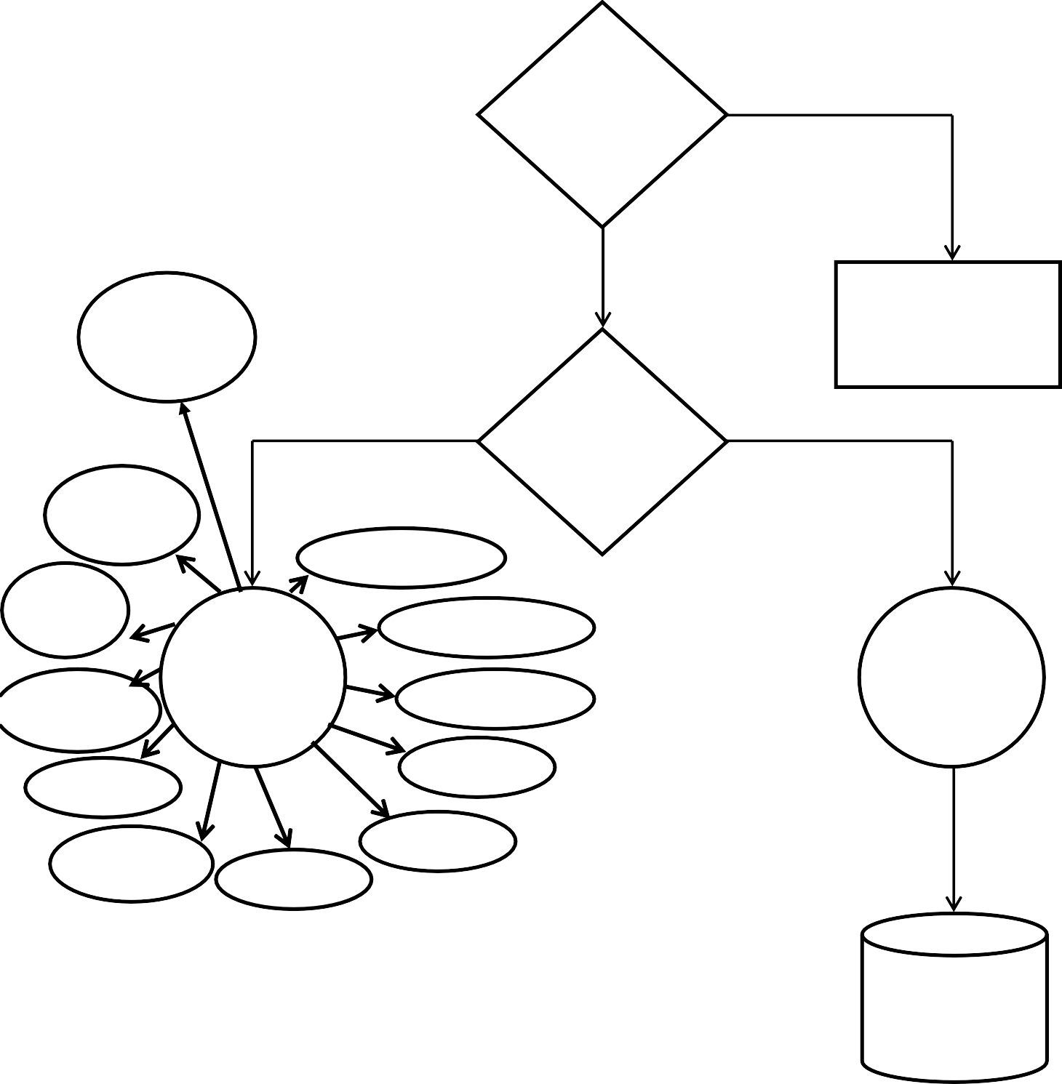

Database

Once source code has been generated, software must be tested to uncover (and correct) as many error as possible before delivery to customer. Our goal is to design a series of test cases that have a high likelihood of finding errors. To uncover the errors software techniques are used. These techniques provides systematic guidance for designing test that

TESTING

1. Exercise the internal logic of software components, and
2. Exercise the input and output domains of the program to uncover errors in program function, behavior and performance

**Steps:** Software is tested from two different perspectives:

* 1. Internal program logic is exercised using white box test case design technique.
  2. Software requirement are exercised using black box test case design technique.

In both cases, the intent is to find the maximum number of error with the minimum amount of effort and time..........................................................................................................

*Testing Methodologies:*

.........................................................................................................

A Strategy for software testing must accommodate low-level tests that are necessary to verify that a small source code segment has been correctly implemented as well as high-level tests that validate major system functions against customer requirement. A strategy must provide guideline for the practitioner and a set of milestones for the manager. Because the steps of the test strategy occur at a time when deadline pressures begin to rise, progress must be measurable and problems must surface as early as possible. Following testing

techniques are well known and the same strategy is adopted during this project testing.

*UNIT TESTING:*

Unit testing focuses verification efforts on the smallest unit of software design- the software component or module. The unit test is white-box oriented. The unit testing implemented. The unit testing implemented in every module of student attendance management system. By giving correct manual input to the system,

the data’s are stored in database and retrieved. If you want required modules to access input or get the output from the End user. Any error will accrued the time will provide handler to show what type of error will accrued.

*SYSTEM TESTING:*

System testing is actually a series of different tests whose primary purpose is to fully exercise the computer-based system. Below we have described the two type of testing we have been taken for this project. It is to check all modules worked on this project. It you want to change any values or inputs will change all information .So specified input is must.

*PERFORMACE TESTING:*

Performance testing is designed to test the run-time performance of software within the context of an integration system. Performance testing occurs throughout all steps in the testing performance. Even at the unit level, the performance of an individual module may be assessed as white-box text is conducted.

This project reduce attendance table, codes. It will generate report fast.no have extra time or waiting of results entered correct data will show result few milliseconds .Just used only low memory of our system. Automatically do not getting access at software. Get user permission and access to other applications.

.........................................................................................................

*Testing Cases:*

.........................................................................................................

|  |  |  |  |  |  |  |  |
| --- | --- | --- | --- | --- | --- | --- | --- |
| Sr.no | Test Case Id | Test Case Name | Test Case Description | Step | Executed Result | Actual Result | Test Case Status |
| 1 | Login | Validate Login | To verify that login id on registration on Database | Enter login id or password and click on login button | Login Successfully or an error message | Successfully | Pass |
| 2 | Registration Form | Information of the user | Successfully | Pass | | | |

LIMITATION

Our Site only provides the cash check in and checkout we doesn’t provide

any card payment in check in and checkout this is our limitation of our site

FUTURE ENHANCEMENT

*Feature of System*

⇨ User friendliness

⇨ Flexibility

⇨ Easy To Modify

*USER FRIENDLINESS*

To make system more user friendly, following action have been taken.

* System Provides Appropriate Messages.
* User can purchase the product.
* Attempts are made to reduce response time.
* Attractive Screen are generated so familiar person can also operate the system very comfortably.

*Flexibility:-*

The System is made as possible as so that it can be used in any kind of situation and accommodate any kind of change in real world.

For that at the time of designing all possibilities were considered and also possible changes in future were considered.

BIBLIOGRAPHY

To develop this “Web application of online information of computer courses” We used ASP.NET as front end and SQL SERVER as back end. We take some knowledge towards automation system from some books and web references that are given below.

* [www.alienware.com](http://www.alienware.com)

REFERANCE BOOKS

* ASP.NET BLACK BOOK
* Web development using ASP.NET